My Feedbacks:

Feedback from business:

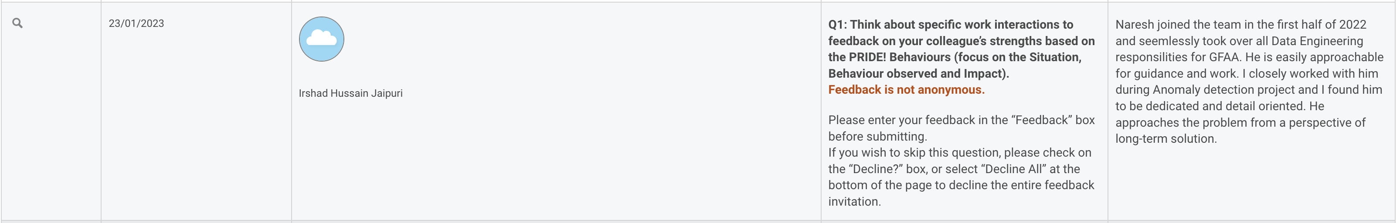

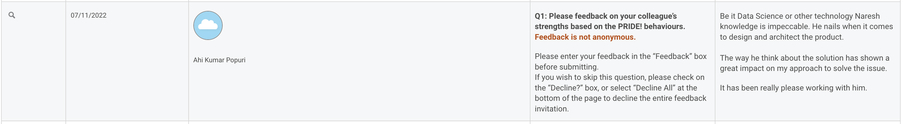

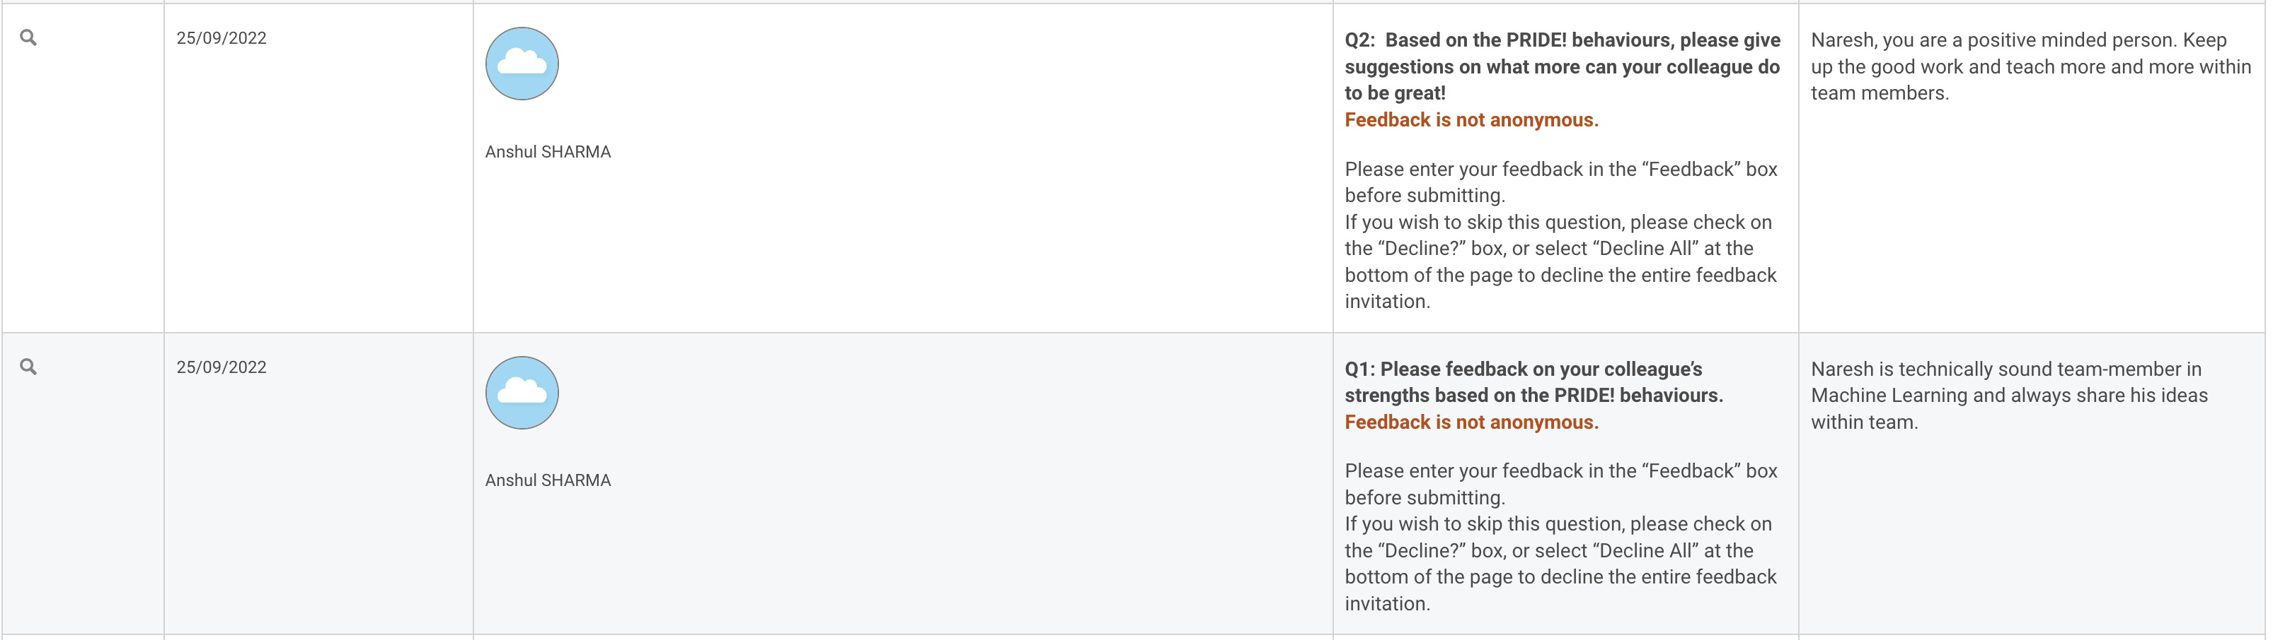

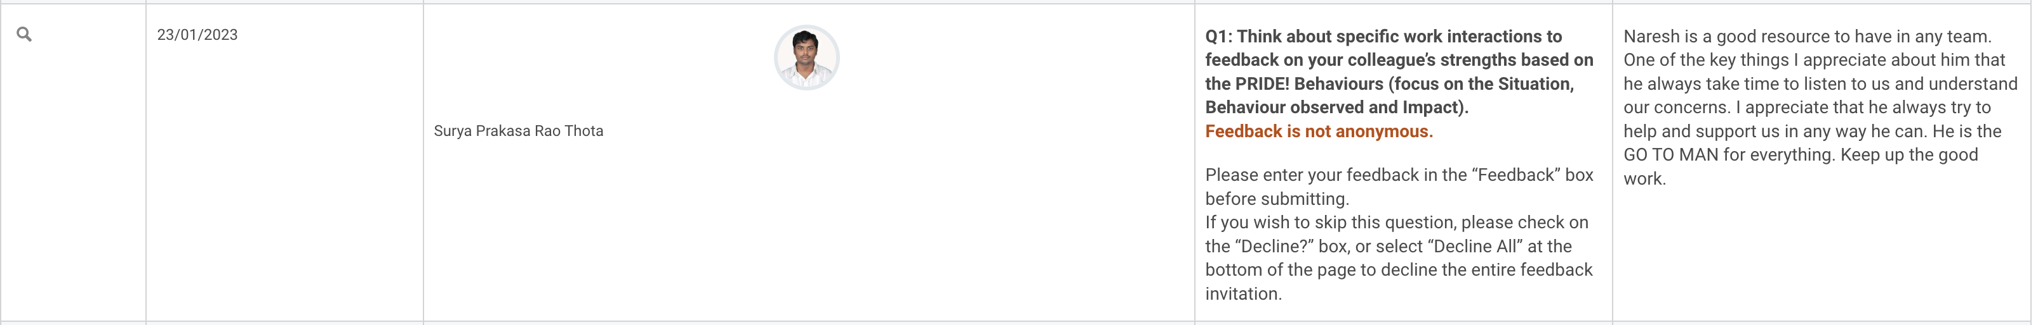



Linkedin feedback:

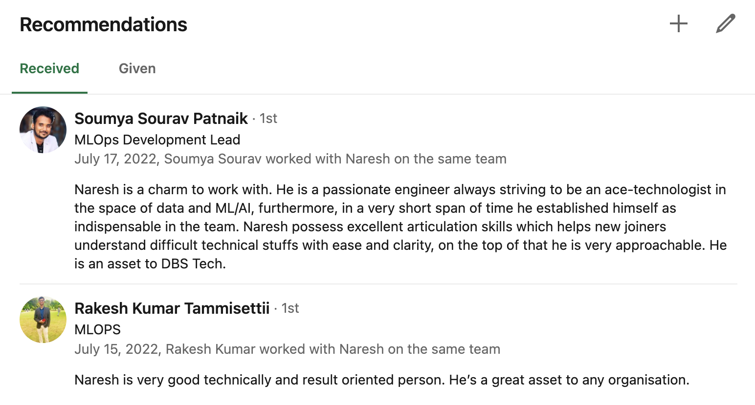

**Other feedbacks:**

